Chapter 4, Solution 13.

Let 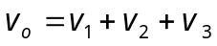, where v₁, v₂, and v₃ are due to the independent sources. To find v₁, consider the circuit below.
10 Ω
2 A
5 Ω
v₁
8 Ω
+
_

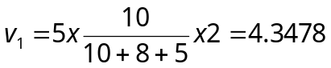
To find v₂, consider the circuit below.
10 Ω
4 A
5 Ω
v₂
+
_
8 Ω

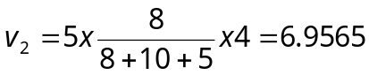
To find v₃, consider the circuit below.

10 Ω
5 Ω
v₃
8 Ω
+
_
+ –
12 V

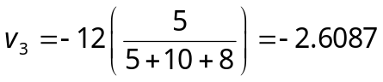

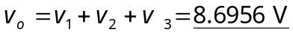 =8.696V.

